[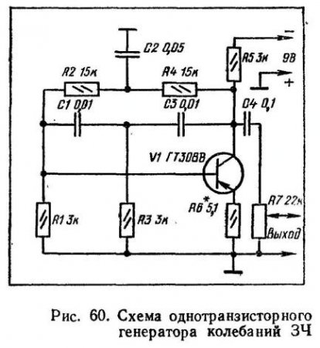](http://radiobooka.ru/uploads/posts/2009-07/1248149473_index.1.jpg)