DEEPERS 10 DD METAL DETECTOR


USERS MANUAL (English)
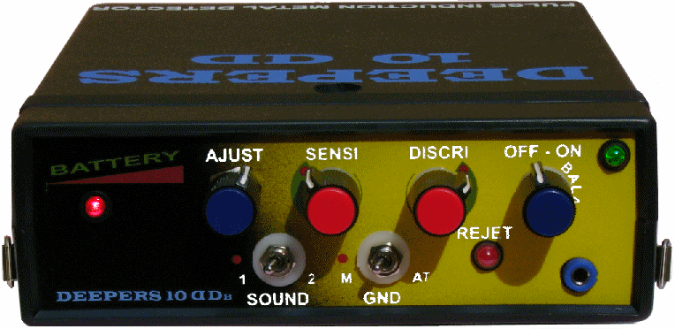
Congratulations on your recent acquisition of a Deepers 10 DD manufactured by Latincom SA Electronic de Mexico (Ltd) under Deepers Metal Detector Company’s exclusive license. This totally new high technology pulse induction detector is a high power tool: it is the best professional pulse detector in its category. It has incorporated into its system the ability to use the double coil system (DD), just by moving a switch on the back of the detector, these specialized coils will be available by the end of the year 2006 and you will have the opportunity to buy them with a 10% discount just by indicating your invoice number. This new detector has also an 18 hour battery pack (instead of the 8 hour on the previous model) which can be doubled or tripled in a few seconds thanks to the interchangeable external battery pack.
Simple to use, solid and reliable, this detector will give you full satisfaction is searching and locating metallic masses even those buried very deeply.
We highly recommend that you do not rush out immediately and start detecting, but rather take time to read your manual carefully and learn how to use your Deepers 10 DD first and get familiarized with the adjustments. This certainly will give you much better results since it is full of advice and information that is indispensable to lead you to get the best results possible.
UNWRAPPING:
Open the package carefully of your DEEPERS 10 DD. The point of our packaging procedure is to safeguard the material during its transportation to any destination around the world.
ASSEMBLING:
The assembly of the unit should not present any difficulty.
Putting together the Commando Arm: Once the ergonomic Soft Grip is adjusted for your grip, tighten the Allen screw with the Allen wrench (included in the package).
Extend the Commando telescopic arm to the height desired, according to your height and lightly tighten the two wing nuts to immobilize it (do not over tighten; this could harm the internal blockage cones).
Assembly of the Elliptic Search Coil:
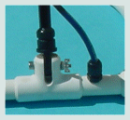
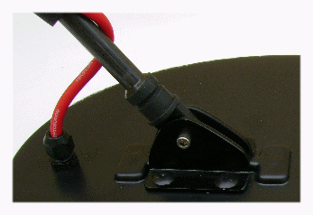
Insert the bottom tip of the Commando arm into the super sensitive elliptic search coil; using the bolts and wing nuts that are made of special Inmag metal (they are not detectable). Tighten moderately with the Allen wrench (included in your package) so that the head is immobilized at a comfortable angle. We only use special nuts and bolts made of Inmag metal because of their strength and neutral electromagnetism; do not replace these with other materials.
Wind the provided cable from the head around the Commando arm and immobilize it using the two Velcro braces included in the package, place the top part of the cable into the security clip situated underneath the handle and press to close. Slide the belt thru the small loop on the back part of the control box, in this way you can transport it on the left side of your waist or you can use the belt to hang it around your neck by looping it thru the two slits on the sides of the box, which ever way you prefer.
Connect the cable plug coming from the elliptic head to the jack marked SEARCH COIL that is on the back side of the control box making sure to plug it in using the canal as a guide. You can do this also with the other heads, the 1mt. x 1mt. search loop, the Double DD search coil or the wand coil. Slightly tighten the security bolt on the connector.
Connect the headsets to the front of the equipment or use the buzzer (internal speaker). When the headsets are connected, the speaker is automatically cut off (there is an extra 20% detection efficiency with the use of the headsets).
Make sure not to have any metal objects in your pockets and that your clothing and foot wear are free of any metal substances (eyelets, rivets, buckles, etc.). Avoid wearing any jewelry such as heavy wrist watches, bracelets, etc. As a general rule, discard any metallic object which could create a parasitic interference during detection.
SEARCH LOOP ASSEMBLING (optional):
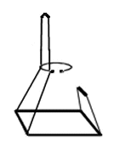
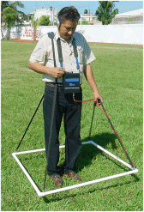
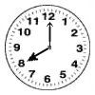
Assemble the 1mt. x 1mt. search loop making sure the tube holes coincide (all red dots on the top) and are free to permit the passage of the conic screws which have to be slid through the bottom. Whenever the inside cable blocks the aperture, the conic end of the screw pushes it aside and finally gets through the other side of the tube. Take time, be patient and careful. Lightly tighten the wing nuts as needed to eliminate any play, (do not over tighten!). Your Deepers 10 DD auto tune has three different types of straps. To assemble the straps for the search loop, connect the long strap for the shoulder on the right side of the search loop and the shorter one on the left side (refer to picture and drawing). Adjust the straps for your height and then place the back strap thru the belt. Buckle the belt so the front strap is also inside the belt. This allows you to have one of your hands free to make adjustments on the equipment which gives great stability while working on land. Attach the straps at the 4 corners and adjust them to the desired height. Position the felt handle in the middle of the straps by sliding them. The search loop must be parallel to the ground at about 10 to 15 cm. high (4 to 6 inches). Connect the cable to the control box, turn it on and proceed to make the basic detector adjustments. The electronic equipment will adjust itself automatically to the type of head being used except for the Double DD search coil which will need to change the switch to Double DD coil setting on the back of the control box. Whenever there is some obstacle such as a big bolder, raise the search loop by lifting the handles and return it to its proper height after that. Due to the Deepers 10 DD high power, it is recommended that the search loop be used by 2 people. One handles the electronics while the other about 1.30 to 1.50meters (4 to5 feet) away to the right or left of the former moves the search loop over the ground.
When using the search coil, the knob SENSI should be at about the 6 to 8 o’clock position, this offers the best stability and efficiency with this detection antenna
Deep detection indication with the Search Loop: A target of importance such as a metal suitcase of 40 to 60 centimeters (16 to 24 inches) will be detected, in a neutral terrain, buried at approximately 2 meters (80 inches) deep, or a big 100 liter (25 gallon) container at 2.5 meters (2 yard 6inches) deep and even a target such as an oil barrel up to 3.5 meters (3 yards 24 inches) deep.
DIFFERENT ADJUSTMENTS ON DEEPERS 10 DD
SENSIBILITY AND DROP GOLD SILVER SYSTEM:

The sensibility of Deepers10 DD system is adjusted through the SENSI knob (short for sensibility). This system allows the detection of Gold and other precious metals with much greater ease and depth than any other detector. One must know that gold in particular, is harder to localize than other metals. Most of the common detector, including the best VLF detectors, only provides mediocre results with such metals; it is rather rare that they find a gold coin or a jewel at 13 to 15 centimeters (4 to 5 inches). The Drop Gold Silver of Deepers 10 DD system eliminates those problems since it works in micro-seconds (the internal clock is set at 8 micro-seconds with the SENSI knob set at maximum, (RED DOT POSITION) and not in milliseconds as it is with the other devices, hence its extreme(superior) ability to detect precious metals even at great depth. When it comes to silver, bronze, copper detection and especially gold prospecting, it is recommended to set the SENSI potency at maximum (RED DOT POSITION) if the terrain permits.
Gold recognition close to the surface:
To see if a target that has been detected is gold, such as a gold coin for example, set the SENSI knob at an intermediate setting and go over the spot again. If there is no sound it is probably gold that you have just found. It is important to take into consideration that the identification of gold thru this method is always certain taking into consideration that the gold is at least 75% pure (18 carat gold) as in a gold coin ( US 10 Dollar gold coin for example). If the target is gold but next to another metal, or deeper, or in a mineralized area the identification will be less certain. Of course, if the target is gold plated the detector will not recognize it as gold. We recommend verifying the position on your equipment of the SENSI knob to determine exactly were gold is identified, since the parameter indication may vary slightly from one apparatus to another. This system is not recommended for depths of over 25cm. (10inches).
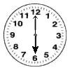

Eliminating small trash: the SENSI knob positioned in the second quarter (from 3 - 6hr position.) lets you miss small trash such as small nails, soda tabs or bottle caps without missing an opportunity to locate an important target even it is buried deep. For those of you that look for gold coins or a strayed jewelry, we recommend working always with the SENSI knob the closest to the red dot as possible.
Note: the sensitivity chosen, if using the elliptic coil, influences on the depth of detection. Depending on the ground mineralization, adjust the SENSI knob so that false signals will not interfere. In a high mineral area, it is preferable to switch to GND on AT to work on auto tune, thus the threshold of your detector will be automatically synchronized with the AJUST, of course you loose a little strength of detection, but targets of a certain size, even thou they are deep, will be detected with ease.
BEACH DETECTION:

On a beach adjust the knob SENSI should be at about the 4 to 6 o’clock position, in this way in the fact that your detector takes no capsule of beer or coca bottle (the plague in detection) and even on the contrary the sound disappears crossing the search coil above such a target but on the other hand your machine will indicate you perfectly the lost objects or the coins. This règlage is very practical for this type of detection and allows to make quickly beautiful finds

FREQUENCY:
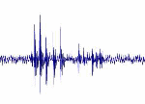
The Deepers 10 DD has a work frequency of 500/540 Hertz. This frequency permits exploring any type of terrain with excellent wave penetration.

DISCRIMINATION SYSTEM:
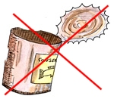
The Deepers 10 DD is equipped with a brand new system of rejection DISCRI of important ferrous targets. This system allows ignoring any important ferrous targets within the first 40/50 centimeters (17/20 inches) of depth where, normally, large quantities of scrap metal (pans, canteens, cans, utensils, horseshoes, ECT.) are found. Thus with the DISCRI system and the and red Led Reject light, when you are above such a target to discard, the Metal red Led light will flash. If the find is of another metal, a silver, bronze or some copper coin quite buried or if the target is deep (which at first glance can be of great interest) the Deepers 10 DD will localize it with precision without loosing its potency and the Led REJECT light does not light up.
VERY IMPORTANT: It is important to know that many treasures or important finds are buried in iron boxes or contain iron or steel metal… But these riches are never buried in the first layers of ground but deeper and this is why it is important to see all targets that are buried deeper.
Note: While searching, it is wise to maintain the detection head about 15 centimeters (6 inches) above the ground to avoid disturbances due to mineralization. If the terrain permits, to search for coins and small objects more successfully and at greater depths, you may put the detector head closer to the ground, but in this case if you are too close to the ground you are at risk of rejecting a good target that may be valuable because the Led Metal light may come on. If this happens with the head too close to the ground, lift it up a little again to 15 cm. (6 inches) from the ground and the DISCRI system will correctly mark if it is a reject or something to keep.
AUDIO SYSTEM:The threshold may be controlled with the internal speaker or the headsets. When the headsets are connected, the speaker is automatically cut off. We highly recommend using the headsets for a more precise and exact detection.
SOUND EFFECT SYSTEM:
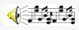
The Deepers 10 DD has a double Sound Effect audio system that synthesizes the threshold. The synthesizer offers more power for the equipment by making a loud threshold on top of a target even if it is very deep or doubtful. This system is certainly efficient on some terrains that are not very permeable to the electromagnetic waves. You may also use this system to analyze an uncertain eco that is very deep, not very clear or to get more power from you detector. To chose this system, put the Sound switch on 2 and use the AJUST knob to hear the strongest threshold (done easily with the headsets) and then with the same knob return slightly to an inferior threshold. Any target that is underneath the detector will provoke a strong threshold.
This system is more effective using the headsets. Normally work with the SOUND switch on a RED DOT
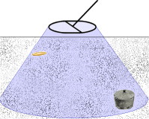
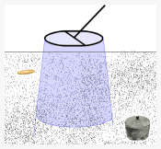
ADJUSTABLE SPECTRUM DETECTION SYSTEM:

Minimum spectrum detection Maximum spectrum detection
The Adjustable Spectrum Detection system of the Deepers 10 DD (adjustable spectrum of detection) permits the rapid exploration of extensive areas to prospect without necessarily having to go directly over the targets to be able to detect them even if the target is over 20 to 30 cm. (8 to 12 inches) away from the head. At the moment that a target is found, the only thing you have to do is reduce the threshold to minimum; with this you automatically close the spectrum of detection to pinpoint the target. You adjust the width of the spectrum with the same AJUST knob that you use for the sound system. The greater the threshold is, the greater the width of the spectrum of detection. The weaker the threshold is, the smaller the spectrum for pinpointing a target. You should reduce the threshold to minimum, eliminate it or elevate the search coil a few inches to obtain only a signal when the target is in the middle of the coil, for the target to be pinpointed. This is very easy and practical.
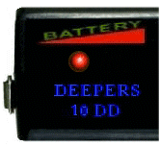
BATTERY CHARGE INDICATOR
Automatic battery check Led. When Led starts to ignite there remain approximately 3 to 4 hours of detection. Quite red Led indicates that it is time to reload the battery or to change some. In final a audible signal also states that the battery is empty.

GROUND SENSOR SYSTEM (GND MODE)
Deepers 10 DD is provided with a new Ground Sensor System (GND switch) that permits exploring with manual tuning of the threshold or by automatic tuning adjustment of the threshold, so you do not have to worry about the grade of mineralization of the ground to prospect. If you do not want to constantly adjust you detector, we suggest working with this advanced system of AUTO TUNE of you Deepers 10 DD detector. Simply switch the GND switch from the M (manual tuning) to AT to operate with the Auto Tune system.
Detecting with the AUTO TUNE system, the unit will automatically adjust for the mineralization of the soil which you go over. The detector will be much more stable and even if some strength is lost (5-10 % depending on the ground) taking into account its great strength of detection, you will still be able to detect targets very deep that other detectors would not find. While using the AUTO TUNE system you can equally use the SENSI knob for sensitivity, it only takes a few seconds to automatically adjust itself.
DETECTION
RAPID ADJUSTMENT OF YOU DETECTOR:
Get away from any metallic object or reinforced concrete (at least 6.5 yards away), assemble the Commando arm and connect the elliptic head (or the head of your choice) to the electronic unit. Before turning the apparatus on, turn the SENSI, DISCRI, SOUND and GND knobs to the RED DOT POSITION and the AJUST knob to the middle, 5 turns of a total of 10 turns (it is important to do this before turning your detector on). Position the detection head a minimum of 15 cm. (6inches) from the ground, turn the detector on with the ON/OFF knob moving it to ON and continue turning towards BALANCE until you find the exact place where the threshold (sound) is found.
Next, turn the AJUST knob (the one that turns 10 times) to obtain the threshold desired (clockwise to strengthen the sound or counter clockwise to weaken it). We recommend that you use a soft threshold when detecting (or even better use the headsets) to be able to continuously control the detector well.
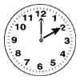
Note: In manual mode (GND on M or red dot); in some high magnetic resonance zones or electrical interference areas the threshold will not disappear from your Deepers when turned on. In this case, simply position the OFF-ON switch on BALANCE at about the 2 o’clock position and reduce the sensibility with the SENSI button until you find the place were the threshold disappears, after this, adjust the threshold with the AJUST knob. With the AT mode, the threshold is only adjusted with the AJUST knob, what ever the mineralization of the area may be or the interference of the area.

While prospecting using the Ground Sensor manual mode (GND on M or red dot) every once and a while depending on the degree of mineralization of the ground, you should use the AJUST knob or put the detector head up or down slightly to return to the preferred threshold (don’t forget that the underground soil changes without you realizing it form above).When using the Ground Sensor on M, any change in the parameters of search will make you readjust the detector again as described earlier with the BALANCE and ADJUST knobs.
WORKING WITH AUTO TUNE (switch GND on AT - It is the easiest and advised search mode.):

It is always preferable to work with your Deepers 10 DD with the AT system on, so as not to be bothered with frequent adjustments to the threshold during the search session.
The Auto Tune on your detector is more “user friendly”, without needing excessive changes of the threshold and will perfectly detect any target underneath the head.
It is important to keep in mind that, in this mode, the detector is in a DINAMIC search mode, the head must be in constant movement on top of the terrain to keep obtaining a threshold. Also when a target has been detected, if the head is no longer in movement, the threshold will disappear.
Before choosing this function, verify that the AJUST knob (total of 10 turns) is half way, approximately 5 turns and that the white line is up ( this is the easiest way to tune your detector on Auto Tune). With the GND switch on M (manual) the detector works in a STATIC search mode so that if the head is immobilized over the target a threshold will be heard all the time.
Turn on your detector and set it on BALANCE for at least 2 or 3 minutes get the threshold you desire with the AJUST knob (the AT threshold is only adjusted with the AJUST knob).

Important: The Auto Tune option conserves the desired threshold adjustment automatically and it is much more stable. You can go back to manual position at any given time by switching to GND on M (manual), in this case you will have to make the adjustments with the BALANCE knob to find the correct threshold again and the fine tune with the AJUST knob.
DETECTOR STABILITY:
The Deepers 10 DD works efficiently at its maximum capacity what ever the chosen program. When turned on it stabilizes itself over a lapse of three to five minutes (warming time and time to reach thermal equilibrium of the internal electronic components) this may call for a new adjustment. A good detection technique never permits the head to touch the ground; it should always be parallel to the ground to be searched and always listening to a low threshold thru the headsets. It is important to keep the detector at the same distance from the ground (6-8 in. off the ground). Using Auto Tune, the detector is the most constant and maintains the threshold that has been previously selected without worrying about the mineralization, humidity or resistance of the ground being prospected.
CONSUMPTION: The average consumption of a Deepers 10 DD is 160 mA/H to 200mA/H (depend of the search coil).
BATTERY DURATION:
With a well charged battery, you will be able to work with you Deepers 10 DD detector for a maximum of 18 hours depending on the kind of search, but taking into account the breaks you take, you will probably have up to 24 hours of detection time without having to recharge or change the battery.

DETECTION SIGNAL - TARGET ALERT:
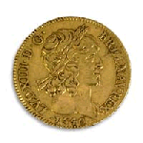
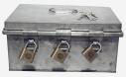
Any object that passes under the detection head will provoke a stronger threshold or sound in the headset and a response on the LED Light REJET if the target is trash in the first 15 inches of depth (38/40 cm.) The maximum threshold corresponds to a target going under the axis of the head. To discard small pieces of metal trash that are found in the top soil, you may select the SENSI knob slightly lower, you may also lift the detector head slightly higher from the ground or reduce the threshold slightly (using the silent search for example) with the AJUST knob… but be careful using these because using them you may loose a target that is very deep. Switching the GND on AT (recommended mode), the detector works on AUTO TUNE and keeps the same threshold selected adjusting automatically to the degree of mineralization of the ground.

Attention:: Never go under a high tension power lines (this could permanently damage the electronics of your detector), do not have mobile phones turned on while prospecting If there is an electrical storm in a radius of approximately 10km.(7miles) to the search area the equipment may give off false signals, stay at least 50 meters (60 yards) away from other detectors, specifically other Deepers…and of course, do not have any metal objects on your person (belt buckles, mobile phones, metallic watches, ect…)

IMPORTANT FOR EFFECTIVE DETECTION:
The Deepers 10 DD has a double internal electrical regulator that offers wonderful stability, which you will be able to verify for yourself during your search sessions. But do not forget that the ground changes constantly (the mineralization, magnetism, conductivity and humidity) without noticing this from above, this is why we suggest that your machine be adjusted on manual (GND on M), according to the soil to be prospected, for detecting targets even thou they are deep. Pay special attention to deep detection. Your Deepers 10 DD will provide you with more satisfaction than any other kind of detector; after all it is a precision professional detecting machine, which needs a little more attention.
PIN-POINTING:
To pin-point a target detected, you must localize the position that corresponds to the strongest threshold and repeat the operation at 90 degrees. The strongest threshold crossing the first corresponds to the center of the target. If there is too much noise to exactly localize a target, you should use the detection head at a little higher height above the ground and do the same operation with a light threshold.
Note: the Deepers 10 DD has been adjusted at our factory and no other internal adjustment is necessary. All the adjustments that correspond to the desires of each individual client can be made possible using the 4 knobs and 2 switches on the front of your detector. Under no circumstance should anyone touch or tamper with the internal adjustments, which have a special guaranteed infrared enamel covering done at our factory.
We recommend that before running out on your first search, you first familiarize yourself with your Deepers 10 DD practicing with target that you have previously buried. This is a good method to see the reactions of this extraordinary machine and its various types of detections, to appreciate its penetrating strength, and to get to know which target gives off which type of signal (with a little more experience).

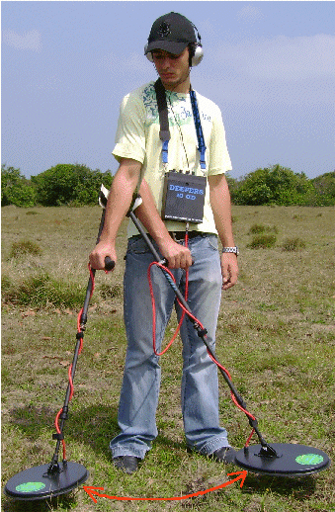
PRACTICE MODE (read carefully): Choose a quite place that is not very contaminated (a meadow, forest or a field away from the city). Verify that there is no echo in the place selected and dig some holes about 1.50mt (1 ½ yards) apart from each other and about 15cm (6inches), 20cm (8inches), 35cm (14inches), and 60cm (24inches) deep (this is enough to begin with). Place the targets inside the holes. In the 15cm (6inche) hole place a 10cm.(4inch) rusty nail, in the 20cm (8inch) hole place a coin, in the 35cm.(14inch) hole place old jam tin can(4/4or 1kg.)and in the 60cm(24inch) hole, place an eight ounce soda or beer can (our universal target) or a small chest of the same dimension. Cover them all up and pack down the soil. Adjust the Deepers10 DD in different modes with the GND switch M (for manual mode) and on GND on AT (auto tune mode) to see how it reacts to these different targets at different depths. Remember to check the REJECT system when you are over the tin can. With your Deepers, localizing these targets will be easy, plus you will be able to make wonderful discoveries even at greater depths. This is the great advantage of the Pulse Induction and specially the Deepers 10 DD because of the latest technical developments and it is the most unquestionable leader in deep detection.
One last bit of advice: Look for places that other prospectors have not checked before like around rocks, trees, prairies, mountains, on the edges of lakes, forests, old mines, caverns or any other place that you think may have something hidden and that is awaiting for you to dig it up! There are thousands of hidden treasures waiting to come out into the light (read our web site chapter, “Millions at your feet”).
Usage of the Planar mono search coil:
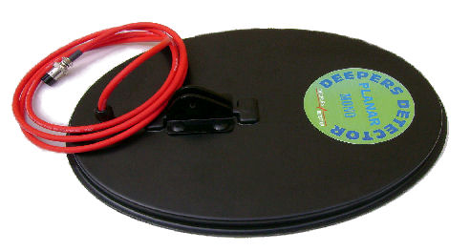

The new PLANAR mono search coil of 25 cms x 35 cm is very light, it weighs only 410 grams and presents a big solidity by its conception to welded edges. The shocks aside during the "sweeping (on a stone, a shrub or the other obstacles) present no problem. Thickness of only 18 mm is the reason for its name PLANAR. Excellent and recommended for any research up to more than a meter thirty depth on neutral ground.

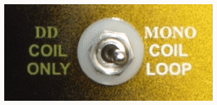

Attention: The Planar mono search coil, the shank search coil and the frame loop are used with the switch SEARCH COIL on the position MONO COIL LOOP

Performances of detection in ground (not mineralized):
With the Planar mono search coil, a gold coin, type Mexican Centenario, will be discovered in more than 35 cm deep, one can of soft drink 33 cl in more than 65 cms and a casket, any bowl or grouping of 35 cm objects x 35 cms will be localized in more than an underground meter. Maximum detection: 150 cms deep for an important volume.
To search for important metallic masses up to 2 or 3 meters (2 to 3 ½ yards) you should use the search loop (optional).

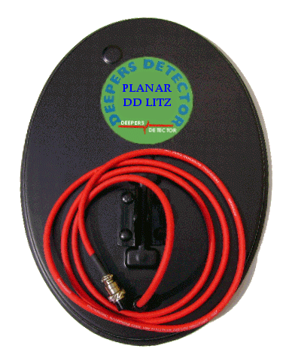
Usage of the PLANAR DD Litz search coil:

These optional search coil of a advanced technology is very appreciated above mineralized grounds (or very polluted), specially for gold or nuggets prospecting, the research of antique coins and also for the localization of deep precious deposits on such difficult mineralized grounds.
Attention: with the usage of a PLANAR DD Litz we have to position this switch on DD COIL ONLY

Usage of the Hypersensitive search coil:

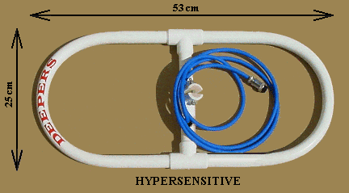
With this new Hypersensitive search coil, we can detect an important metal mass in two meters deep. This search coil also detects in more than 50 cms around a target, it is not thus necessary to cross just above to locate it, what is very practical because in a lot of case an interesting deposit can be under a rock, a tree which in increased or quite other obstacle.
With this search coil it is sufficient to pass next to the obstacle to detect perfectly what exists below. This new Deepers Detector search coil is the most powerful of the market and agrees particularly up to 2 meters deep for any serious research in difficult condition (ground containing numerous obstacles or rocks)
It is hollow in its center what allows to show constantly the canvassed ground. High-quality, very resistant manufacturing, is not afraid of the knocks against rocks or trees, furthermore it is totally submersible. Dimensions: 53 cms x 25 cms (20,87" x 9,85").

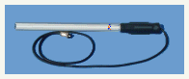
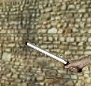
The Deepers Wand search Coil is very effective and precise when searching in old walls, mansions, ruins, warehouses, caves and under ground caverns. These searches are usually done in two steps, first with the elliptic head, marking any finds and then with the wand to pinpoint the target. The Wand Search Coil is an indispensable tool which complements the elliptic head for searches of this kind. The Wand Coil should be used parallel to the wall (as shown in the picture), as close as possible to the wall to obtain the best strength and detection.
Depending on the echo, you may localize the target found and determine its form, electrical cables, a nail, a metal tube… a round form or rectangular form, that could be a box or chest with many valuable things inside.
The presence of a hidden metal object is identified by the higher volume of the threshold thru the headsets. A hidden metal chest in an old wall for example (the most commonly found in old houses), will be easily detected and localized with precision even if there are nails, metal tubes or electrical wiring close by avoiding useless digging. The wand coil is an indispensable tool for these kinds of searches. This head is connected directly to the electronic unit (the same as the elliptic head or search loop is connected). Make the necessary adjustments for a slight threshold, the same as for the other heads, the wand coil should be used as close as possible to the wall (as shown in the picture), for the most precise reading.
Note: with the usage of the wand search coil to settle SENSI to a lower position so as to obtain a correct sound

RECHARGEBLE CEL-GEL SECURITY BATTERY PACK:
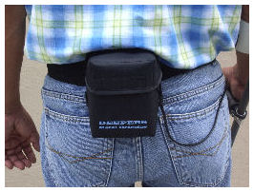
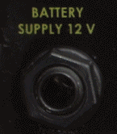
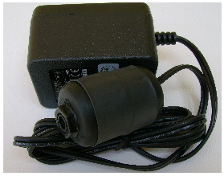
Energy and power are totally inseparable, if you want power, you need a lot of energy, and this is a fundamental rule for detection. Deepers Metal Detector Company is always looking for technology that is state of the art. This is why for the DEEPERS 10 DD we have chosen the Rechargeable Cel-Gel battery technology. These batteries offer multiple advantages in comparison to the internal batteries of previous models. The previous ones only offered 8 hours of use and they were impossible to change on an outing. The battery pack for the Deepers 10 DD offers a great storage capacity of 4 amps, plus a great price for those who want to have several batteries on hand. For your convenience, they can be purchased at any electronics store around the world. The battery pack is contained in a special pouch that is worn around the waist and is kept in place by way of a highly resistant belt that is adjustable to your waist. One 12 volt 4 amp Cel-Gel battery pack will give an average of 18 hours of continuous use. To use, just plug the jack into the connector on the back marked BATTERY SUPPLY 12V.
RECHARGING THE CEL-GEL BATTERY PACK:
Plug the charger into a 110 or 240 volt electrical outlet, it will automatically adjust to the type of current. Next, plug the connector from the battery pack into the charger. Recharging may take from 8 to 14 hours depending on the original charge. The internal regulator optimizes the charge but we always recommend not charging for over 14 hours. Fast charging for 4 to 5 hours will give you 75% of the battery power. We use chargers of the new generation of type Switching Adapter because they are much more reliable and more precise for recharging Cel-Gel batteries. When done charging, disconnect the charger from the electricity and then disconnect the charger from the battery pack.
The battery is protected by a fuse (in the battery bag). In case of break replace it by a new fuse of 2 or 3 Amperes. The accessories bag contains 2 extra fuses .ADVICE: avoid charging your batteries more time of maximum load indicated higher.
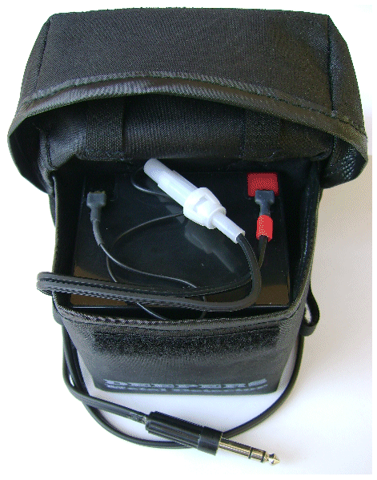
To change the fuse open the white tub and take out the old fuse and replace it by a new one (4 or 5 amperes).
Attention: We highly recommend charging far way from any flammable or combustible material, in a well ventilated area, never in an enclose area. On a concrete block or a glass top table, in a well ventilated area are the most recommended places for recharging. Our company will not be responsible for any security incidents or accidents if our recommendations are not followed.
Recommendations: We recommend recharging the battery pack 3 to 4 hours before going on a detection expedition. Never store the detector or the battery pack in any humid place, hot or oxidizing atmosphere (remember cars get very hot in summer). In case it begins to rain during a detection expedition, protect the equipment in plastic bags. If you are not going to use the equipment for a long time, we advise you to recharge the battery pack from time to time (around every 3 months).
- This charger type Switching Adapter is designed for use with the battery pack’s Deepers 10 DD metal detector. This charger is a regulated charger that stops charging when the battery is fully charged, extending the life of your battery.

Connector battery plug Deepers 10 DD
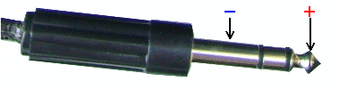
If we have to change the cable of the battery or the final connector, respect the + and the - such as they are indicated on the photo.
THE DEEPERS TELESCOPIC COMMANDO ARM
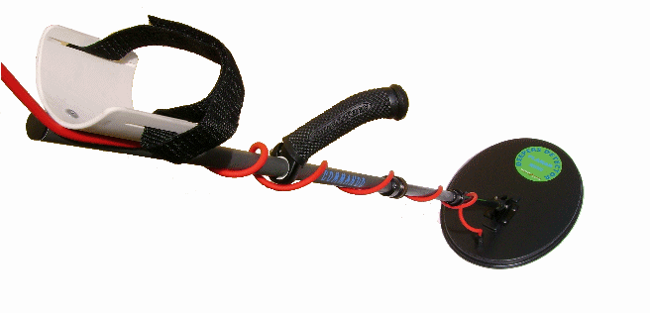
Retracted Commando arm- only 24 inches long:
This brand new high Tec arm offers exceptional qualities: military type design, super light weight only 480gr (1 pound), very comfortable and retractable. You have to try it to understand the great technical advancements it has. Of course the arm is known as “Commando”! All the military detectors have similar high quality arms because of the rigorous fabricating norms that are placed on companies by the armed forces. Duraluminox is a special alloy for tubes of high resistance with three coats of anodizing on the tubes, aircraft quality. Ergonomic handle made of cold forged aluminum with an angle of 12 degrees, a grip covered with soft rubber “Soft Grip” for greater comfort and grip.
Adjust for height and proper angle (according to the anatomy of each person) by using the Allen type bolt embedded in inox (the Allen wrench provided for the arm). The telescopic arm will reach 1.50mt (60inches) in length and retracts in an instant to 63cm.(25inches) which permits you to store it and transport it everywhere with ease. Once the arm is adjusted to your height, you tighten the two bolts until firm. The results are a highly technical and precise arm…Equipment destined for professionals.
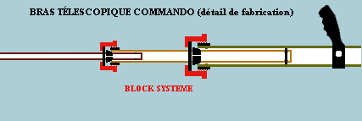
TECNIQUE OF COMMANDO ARM:
Adjust the arm to the desired height of the user and tighten the two bolts that press the cones against the tube. Use the Velcro band to secure the arm to yours. No other company offers such a wonderful degree of perfection and advanced technology. With the “Commando” arm you can search for hours on end without getting tired, total comfort… and you can retract it in seconds for transporting!

MAINTANCE OF THE COMMANDO ARM:
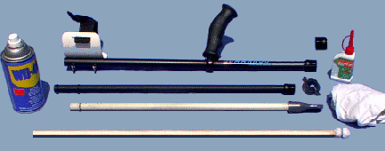
Take the two parts of aluminum arm apart separating the tubes with a single good tug. The fiberglass tube is taken apart in the same manner. Unscrew the bolts (careful not to lose the two cones that are inside each bolt). Place a soft cloth dipped in thin oil around the tip of a thin stick (the same sticks used to clean fire arms- you can make one of wood or buy one at any armory). Do the same operation with a new cloth sprayed with a type of WD40 or similar product; proceed with this same operation for the aluminum tubes also. Clean carefully the plastic cones, bolts and the surface of the tubes with the same thin oil- do not use gasoline or products with detergent. Lightly grease the tubes and cones with silicon grease and assemble with a single hard movement holding the two tips firmly and hitting down to slip one inside the other. Slide the tubes in and out of each other several times so the grease gets on the inside of the tubes. Clean the excess grease off with a clean dry cloth. We recommend that after each use, you clean the arm with a clean cloth before retracting it.
MAITANANCE: the DEEPERS 10 DD does not need any special maintenance. To clean you unit before putting it away, use a damp cloth and then dry it with another clean dry cloth. Do not use detergent, alcohol, petroleum products or chemicals. Do not submerge the unit in any liquid. The elliptic head is sealed and can be rapidly submerged in puddles, rivers, lakes or beaches (but it is not recommended). The headsets may be replaced by any other low frequency headsets of the same type.
CARACTÉRISTIQUES GÉNÉRALES DU DEEPERS 10 DD:

Electronique: Pulse Induction System – Horloge de sensibilité du délai en micro seconde (8 microsecondes réglée à son minimum (Point Rouge) – Fréquence de pulsion : ~ 800/950 pulsations par seconde (Hertz) - Boîtier en ABS haute résistance - Circuits intégrés et transistors spécialisés - Protection polarité d’entrée de charge ou d’alimentation – Auto régulation de l’alimentation à 2 étages – Ajustage du spectre de détection selon volume sonore - Sensibilité de détection maxi pour les cibles en or et argent grâce au système Drop Gold/Silver - Discrimination et reconnaissance de l’or – Rejet ajustable de la hauteur des ferreux importants ou métalliques dans les 50 premiers centimètres de profondeur avec indication par Led intermittente rouge – Système Ground Sensor permettant soit un réglage manuel du son en balayage statique ou en Auto Tune avec balayage dynamique en régime automatique du niveau sonore - Ajustement du son à réglage manuel par potentiomètre de précision à 10 tours - Sound Effect système synthétiseur permettant de mieux identifier les cibles douteuses ou profondes – Système sonore à deux voies, par buser interne ou au casque – Booster automatique d'indication de cible – Indicateur de batterie à recharger par Led rouge flash - Auto ajustement selon la tête utilisée + switch de choix entre têtes normales et tête DD Litz - Alimentation : Batterie externe gel/plomb de12 Volts 4 A - Protection par fusible (fusible de 2 ou 3 A). Consommation : moyenne 180 mA/H. Unité électronique totalement tropicalisée. Bras télescopique Commando haute technologie (480 grammes, se plie en 63 cm). Tête standard PLANAR mono elliptique super sensitive ultra légère (410 grammes) de 25 x 35 cm pour recherche jusqu’à 130 cm de profondeur, en option : têtes double bobinages fil de Litz (DD), cadre de 1 m x 1 m, tête bâton. Casque audio haute fidélité - Chargeur 110/240V de Type automatic Swiching - Sac à dos de transport Deepers Explorer. Instructions d’utilisation en Français (Espagnol ou Anglais). Garantie des performances de détection en profondeur et du système de discrimination et rejet (voir la garantie jointe du détecteur). Garantie matériel : 12 mois pièces et main d’œuvre (les batteries et le chargeur sont des éléments hors garantie). Transport aller et retour en cas de retour à nos ateliers pour réparation ou réglage, à la charge du client.
Document non contractuel: Deepers Detector et Latincom Electronique SA se réservent le droit de modifier parties des caractéristiques techniques annoncées notamment pour une amélioration de la performance de ses matériels.

NORMES INTERNATIONALES DE SÉCURITÉ: Le Deepers 10 DD répond aux normes américaines et européennes en matière de sécurité concernant les appareillages électriques et électroniques (Application of Council Directive 89/336/EEC – Standard to which conformity is declared : EN-50081-1 / EN50082-1).
OPTION
Search loop: this 1x1mt. (40 x40 inches) an extremely sensitive head that will search up to 3 mt. (over 3 yards) deep. It comes complete with a transportation bag (the search loop comes apart very quickly and is put away much like a fishing rod).
Wand Search Coil: this is a 33cm.(13inch) long by 2.5cm (1inch) in diameter extra sensitive search wand specialized for finding “lost nails” in forestry work, veterinary work, public works, industry, wall searches, security searches and may other applications.
Planar DD Litz search coil 25 x 35 cm: Ideal: doble coils, Ideal for fine researches, gold prospecting and in mineralized ground.
Hypersensitive search coil of : 53 cms x 25 cms (20,87" x 9,85"). With this new Hypersensitive search coil, we can detect an important metal mass in two meters deep. This search coil also detects in more than 50 cms around a target, it is not thus necessary to cross just above to locate it, what is very practical because in a lot of case an interesting deposit can be under a rock, a tree which in increased or quite other obstacle.

****************
STORING YOUR EQUIPMENT:

Disconnect all the external accessories (battery and coil) and store in a dry place (in the case and if possible in an airtight bag). If storing for a long period of time, we recommend recharging the battery pack every 3 months.
DISCONECTING THE BATTERY PACK OR CHANGING THE BATTERY:
Open the battery pack, carefully disconnect the two wires from the terminals, do not pull on the wires, take the battery out and replace with new battery Cel-Gel. Connect the two new wires to the battery paying close attention to the polarities, the red end of the wire connects to the red side of the battery (+) and the other wire to the other side (-).
CLUB LATINCOM:
As a member of Club Latincom, you will receive on a regular basis thru your email, technical “Zoom” notes about the best usage of the DEEPERS10 DD. These notes are written with questions and answers from our clients, they are very informative and have interesting information. Read them carefully and you too will soon be a real expert in the art of deep detection. You may also check our web site (http:www.metaldetection.net).
Note: Latincom-Mex, SA and Deepers Detector Co. will not be held responsible for searches done with Deepers equipment or done in areas such as in prohibited areas, archeological area, or protected areas.
Our list of clients is strictly confidential and reserved for our company use only. We will not publicize or give out information about our clients.
WARNING!
Any metal detector may discover underground power lines; explosives or other items which when struck could cause personal injury. When searching for treasure with your Deepers Detector, observe these precautions:
- Do not hunt in an area where you believe there may be shallowly buried underground electric lines or pipes.
- Do not hunt in a military zone where bombs or other explosives may be buried.
- Avoid striking any line known to be or suspected to be carrying electrical power.
- Do not disturb any pipeline, particularly if it could be carrying flammable gas or liquid.



Very nice nugget, over 365 gr., discovered in Australia with Deepers Detector at 15 inches deep in a Hot Rock ground
Latincom-Mex SA de CV - 149 Calle Balboa – 94294 Boca del Río VERACRUZ - MÉXICO
Licence Exclusive Deepers Detector Co
Email: latincom@deepers.net
Tel: (52) 229 937 96 12 – Fax: (52) 229 986 19 00 – Toll free in México: 01 800 987 30 50
INTERNET ADDRESS: http://www.deepers.com
http://www.metaldetection.net - http://www.detecteur-de-metaux.com

